# SettingupApplicationEnvironmentCreateIBMCloudAccount

**Step1.**Navigatetoibm.com/academicandregister withyour smartinternzmail

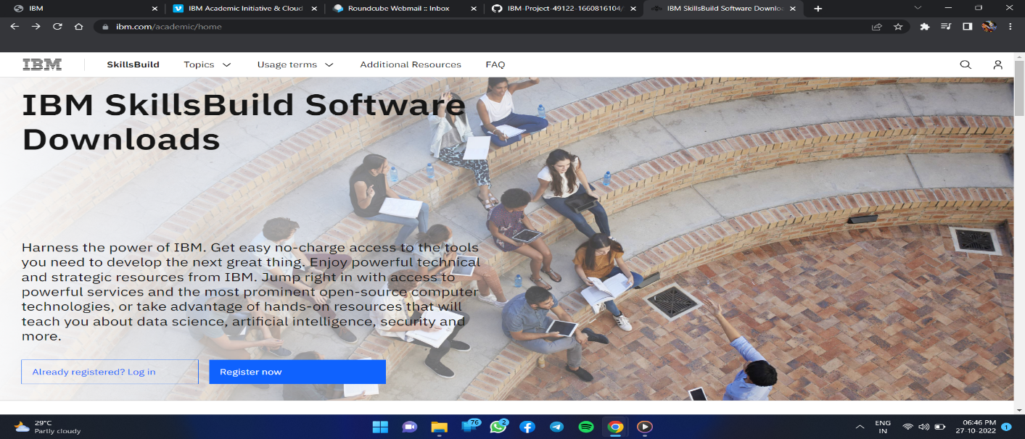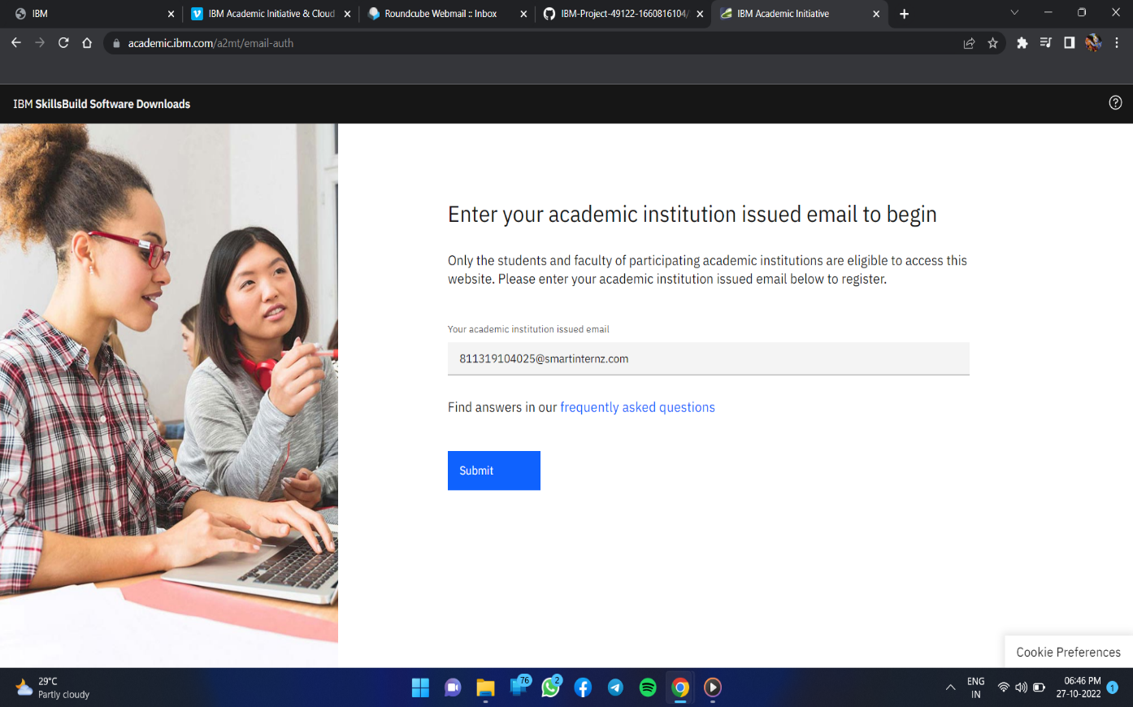

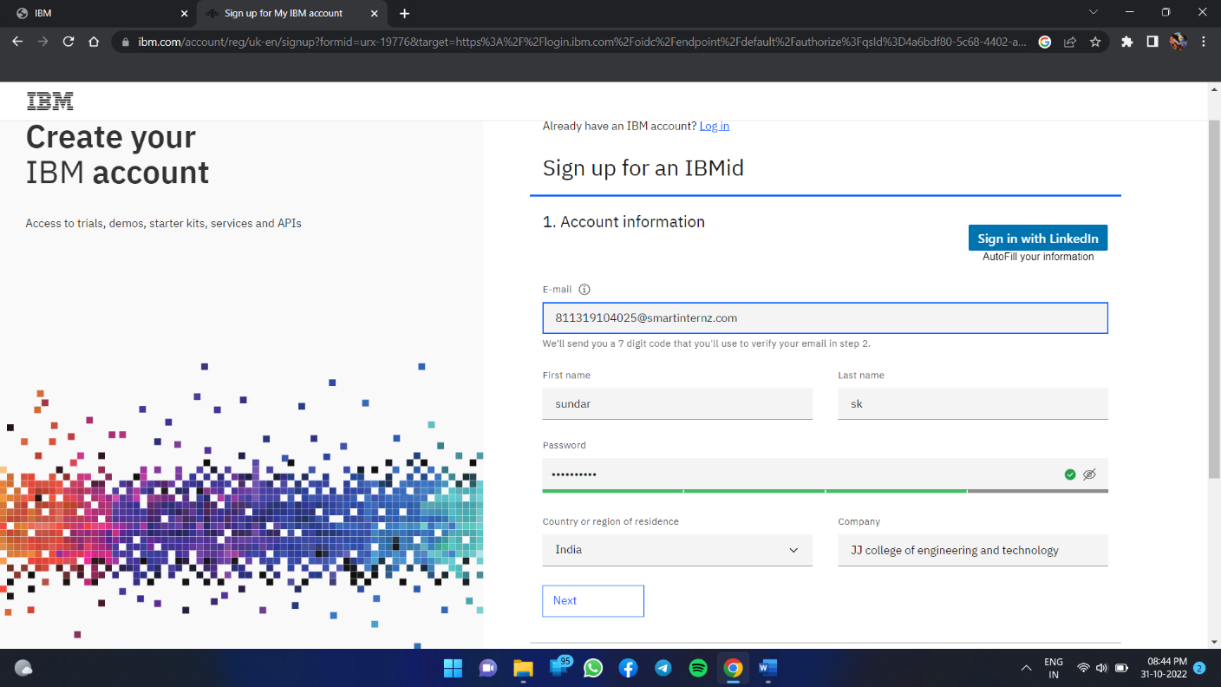

**Step2**:Nowgotocloud.ibm.comandloginwithyourregisteredmailidalongwithcouponcode obtainedfromibm.com/academic

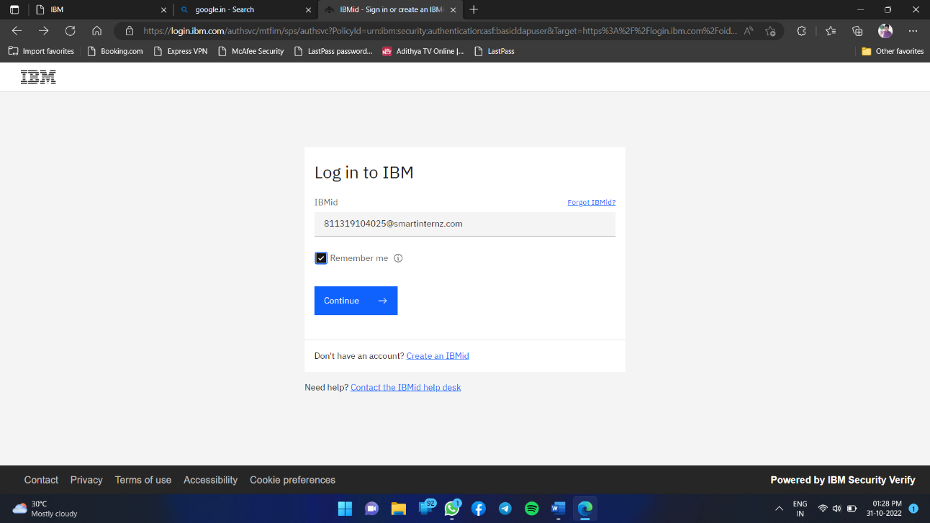

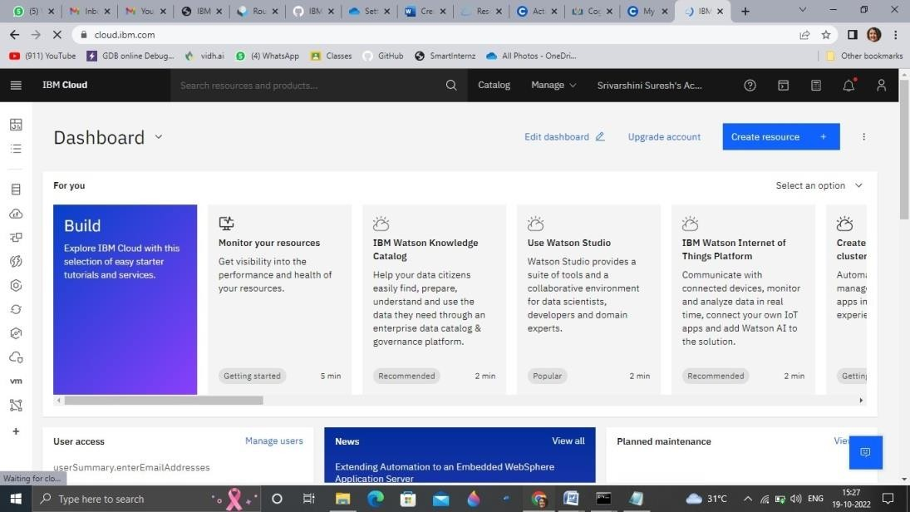

# Output:

Cloudaccountcreatedsuccessfully.